

**EXPERIMENT REPORT OF ASSEMBLY LANGUAGE**

Assignment 1 Experiment 4

NAME : ABID ALI

STUDENT ID :2019380141

DATE : 06/30/2021

SUBMITTED TO :PROFESSOR Yin LU

**Problem Description:**

In this experiment, a piece of 8259 is used to expand the hardware interrupt source of a 8088 processor from one to eight. In its interrupt request IR0, a spin button is connected. When we press the spin button, a high level input will generate a interrupt request. The PIT 8259 is set to be working single piece, normal EOI, level triggered, slave buffered mode, and the interrupt number for IR0 is 40H. As is shown in Figure 5.1 and Figure 5.2.

On the other side, a latch buffer chip 74LS373 is used to interface 8 led lights, and this unit is used as the output device of experiment.

You are required to do:

1. Program the PIC 8259;
2. Write a interrupt service routine (ISR), which is a far typed sub procedure. In the ISR, you are required to change display of the lantern, and move the light upward. If the light has already been the top led, then roll back to the bottom one;
3. Register the ISR to the operating system, and run your program with the hardware schematic design.

**Code:**

.MODEL SMALL

.MODEL SMALL

.STACK 32

.DATA

PORT_LED EQU 68H

PORT_8259LOW EQU 60H

PORT_8259HIGH EQU 62H

pattern_code db 01H

.CODE

MAIN PROC FAR

MOV AX, @DATA

MOV DS,AX

CLI

;TODO1: regist ISR

PUSH DS

MOV AX,0

MOV DS,AX

mov SI,40h*4

MOV BX,OFFSET ISR

MOV[SI],BX

MOV BX,SEG ISR

MOV[SI+2],BX

POP DS

;TODO2: initialize 8259 cmd1,2,4

MOV DX,PORT_8259LOW

MOV AL,00010011B ;ICW 1

OUT DX,AL

MOV DX,PORT_8259HIGH

MOV AL,40H ;ICW 2

OUT DX,AL

MOV AL,00000001B ;ICW 4

OUT DX,AL

;TODO3: light the LSB light

MOV DX,PORT_LED

MOV AL, pattern_code

out DX,AL

STI

FIX_BUG:

MOV DX,60H

MOV AL,40H ;dump 40H, which is the int number, to data bus

OUT DX,AL

JMP FIX_BUG

MOV AX, 4C00H

INT 21H

MAIN ENDP

;;==============================================================

;SubrOUTine: ISR

ISR PROC FAR

cli

PUSH AX

PUSH DX

MOV AL,pattern_code

ROL AL,1

MOV DX,PORT_LED;

OUT DX,AL

MOV pattern_code,AL

MOV DX,PORT_8259LOW

MOV AL,20H

OUT DX,AL

POP DX

POP AX

sti

IRET

ISR ENDP

END MAIN

**Screenshot:**

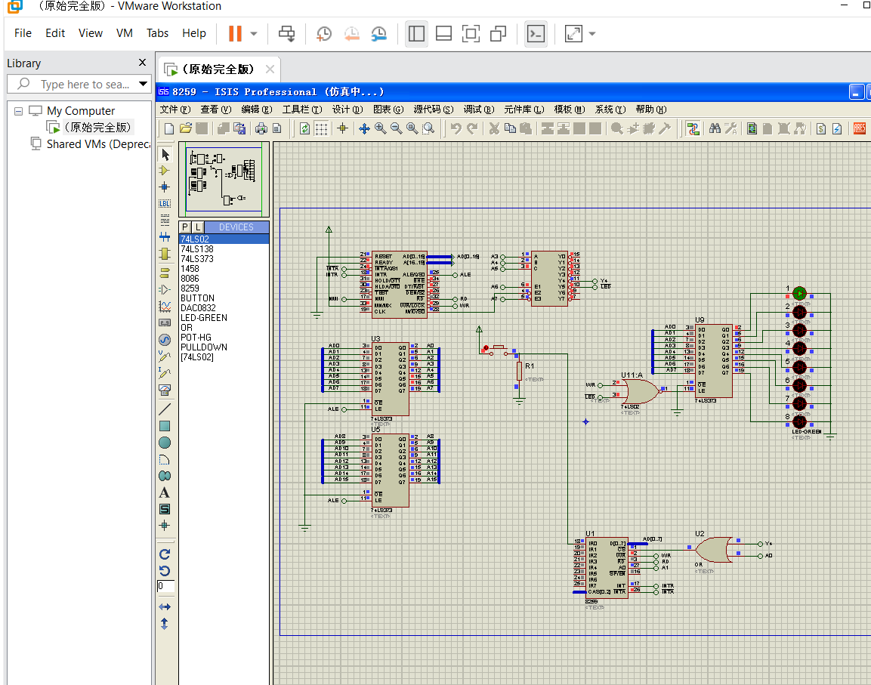

Figure: The hardware schematic design

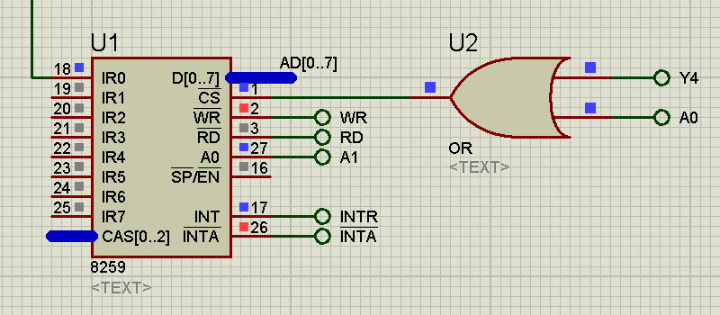

Figure: The PIC 8259

**Debugging:**

This is a new IDE for me ,I have never used it before .So,at the beginning ,I couldn’t understand the use of so many features.Eventually,after watching video.

There is some bugs with the 8259 component of Proteus software. It will not response to the second round of INTA signal. Thus 8086 will not retrieve correct interrupt number from 8259.

As a result, we must ensure that when the 8086 is handling the interrupt request and try to retrieve interrupt number from 8259, the correct interrupt number appears in the data bus. We satisfied the requirement above by output the interrupt number 40H to a null port in a continuous loop.

**Attachment:**

**1)** **Exp-4_ assignment-1.docx**

**2)** **Exp-4_ assignment-1.pdf**

**3)** **lantern.asm**

**4)** **8259.DSN**

**5)** **8259.BMP**

**6）Exp-4_ assignment-1.mkv**

**Acknowledgement:**

I complete this assignment by myself by using online videos and taking help from online.The most useful help from teacher’s hint given in question ,the theory class and the lecture note from the practical class